horizontal line

Cheap Carpool

**--only place for your cheap affordable ride!!!**

# Author: Sanil Jain

# Project Description

I propose to design a system that provides a user with rideshare/carpool facilities available around him. A user is provided with a feature to find local passengers with similar travel plans, common routes or even common destinations, thus providing cost-effective transportation, reduce pollution due to traffic emission and also make easy cash on the way. I have observed that students at my university post on social media platforms like Facebook i.e. in university groups about various rideshare/carpools opportunities in order to save some cash, not only this sometimes they also use class discussion forums like Piazza to find some people to share their ride. The proposed system aims to provide such users an easy, fast and convenient way to find people around them looking for a carpool. The users using the system shall have to be registered and verified with the application. Users are provided with login ids and passwords. User can post about a carpool or look for one. System will use Google API for calculating routes, distance and time to provide end user with various details. The system will also provide carpool reviews and rating system to develop trust amongst various users. A user setting up a carpool will decide a base price for it, users interested for it will be provided with various facilities to negotiate the price for a carpool. System will maintain profile of various users which will include his public information like name, email Id etc and also customer ratings. All this data would be saved as a part of database. A user who has added a carpool opportunity may also take it down.

# 

# 

# ACTORS

**ADMIN**

He is the super-user of the system. Admin is granted all the privileges to access the entire system. Admin has access to all the user profiles, carpool listings, current requests in short the whole database. Admin can activate or deactivate user accounts. Admin also manages reports that are list of spam reviews or ratings and may also take necessary action against such users.

**GENERAL USERS**

Basic User requirements:

1. For using the application that is posting/requesting rideshares a user should be registered.

2. An On-goer or an unregistered user can just search for a carpool, he cannot post one. In order to even request to join an existing carpool user should be registered.

Following are the primary or general users for this application

**1. Existing/Registered users**

Existing or registered users have a maintained profile. They can request or post a carpool opportunity, browse through other user’s public profile. They can communicate with other users for carpool opportunities.

**2. Unregistered/ On-goer User**

Such users can just look through the available carpool listings and users offering it. In order to communicate with such users they need to register with the application.

# ARCHITECTURE

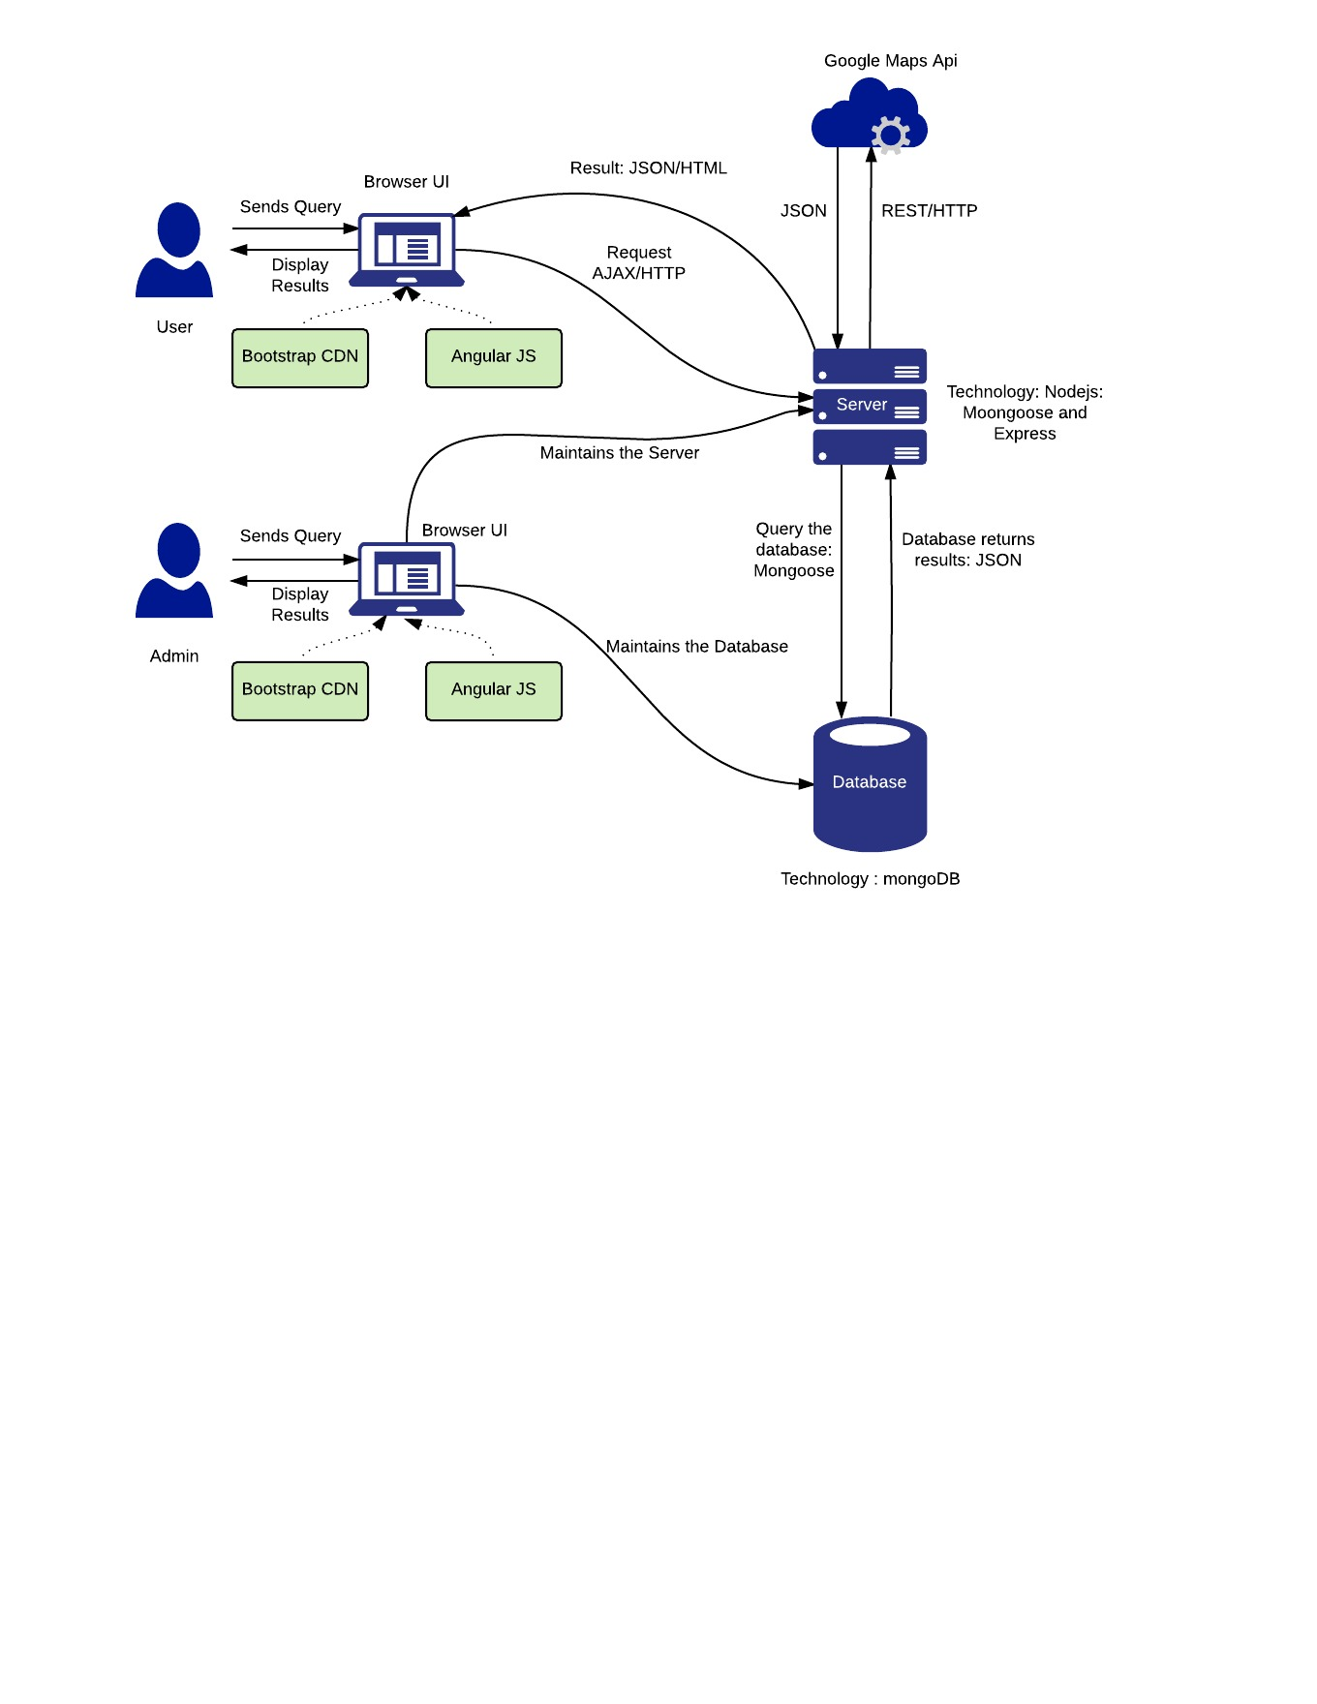

# 

# USE CASES

**1. User Sign-up**

* User enters url on the browser
* User clicks on the sign-up page on the homepage.
* User enters First Name
* User enters Last Name
* User enters Email
* User enters Password
* User confirms Password
* User enters Country
* User enters State
* User enters City
* User enters Address
* User enters Zip code
* User enters Contact No
* User checks terms and conditions
* User clicks “Sign-up” button after entering all the details.

**2. User Searches for carpool (Registered User)**

* User logs in with his username and password
* User searches for carpool by entering keywords for location(source & destination)
* User selects city from the drop down list
* User clicks on search
* User is given a list of available carpool/rideshare
* Since logged-in user, he can see details of a single listing by clicking on know more option.
* User can click on message user/request carpool option to communicate with the other user to participate carpool.

**3. User Lists Carpool/Rideshare opportunity**

* User needs to be a logged in i.e. verified user for accessing this privilege.
* User clicks on create a CarPool option to create a new carpool
* User adds the source and destination for the carpool
* User adds time and date of the carpool
* User enters basic information about car
* User sets base price per member for carpool with number of members/seats
* User adds additional comments or information
* User clicks on create to create a new carpool opportunity.

**4. Customer review and comments**

* User logs-in with a username and password.
* User clicks on Review Hyperlink.
* User enters email of the person for whom he needs to add a review
* User adds a review
* User adds a rating
* User clicks on submit button.

**5. User files a complaint/report**

* User logs-in with a username and password
* User clicks on Report link
* User inputs email of the person he needs to report about
* User selects a subject for complaint from a drop down menu
* User enters comments about it
* User clicks on submit button

**6. User Replies to Messages**

* User logs in with email/username and password
* User goes to profile link from navigation bar
* User clicks on Message Box tab
* User selects a conversation
* User replies to the message

**7. User Searches for carpool (Unregistered User)**

* User opens the url on his browser
* User searches for carpool by entering keywords for location in city
* User selects a date range
* User is given a list of available carpool/rideshare
* Since unregistered user, he cannot see details of listing by clicking on know more option
* User is redirected to register page if he clicks on know more option

# CLASS DIAGRAM

# Carpool Class Diagram - Standard.jpeg

# Moqups Link:

Given is the link for wireframes of the project:

<https://moqups.com/SANIL15/yBdEA8W5>